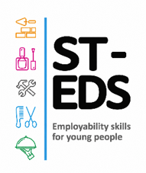
St Edmunds Society
Home Education Pathways
Helping home-educated students discover their potential through hands-on vocational learning.
A welcoming part-time college experience for home educated learners aged 12–16.
Discover  Try practical, creative and vocational subjects in real college spaces. | Grow  Build confidence, independence, communication and study skills. | Progress  Prepare for post-16 study, apprenticeships, training or employment.

Why choose us?
✓ Flexible learning  Part-time study designed to complement education at home. | ✓ Supportive staff  A calm, welcoming environment with guidance from college tutors and welfare.
✓ Real college experience  Use specialist facilities and learn alongside other young people. | ✓ Next-step focus  Support to build confidence and plan future study or training.

What can learners study?
• Vocational tasters • Creative subjects • Life skills • Progression planning
Mechanics, multi-construction, hair and beauty, health and social care, catering.
Ready to find out more?  Book a visit, speak to our team, or ask about available places. | APPLY NOW  https://st-eds.org  chelsea.pegg@st-eds.org.uk  07511177938

Places, entry requirements and course availability may vary. Add your application deadline, open event date or QR code here.

