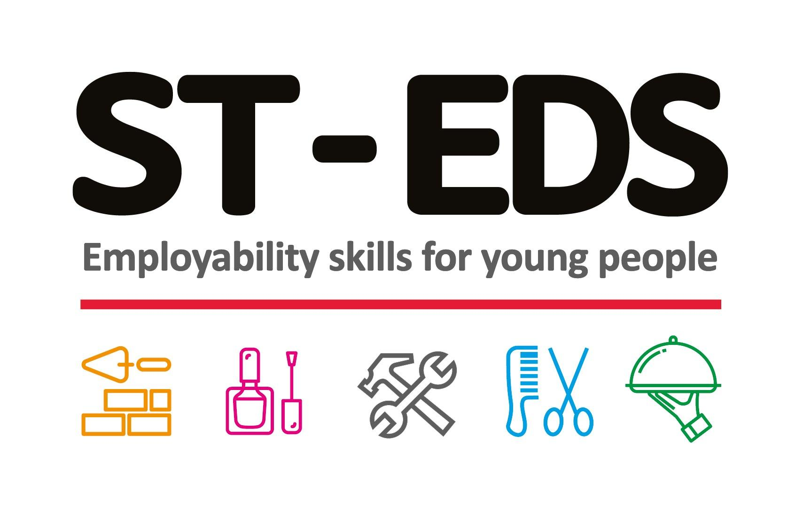
St Edmunds Society
Pupil Specific Risk Assessment

Name:
DOB:
Gender:
Ethnicity:
Date of Assessment:

Has the student had any history of the following?
(Please tick all that apply and elaborate)

Incidents involving the police
Damage to property
Violence
Violence towards peers or staff
Verbal abuse towards peers or staff
Self-neglect
Self-harm
Arson
Sexualized behaviours/offences
Alcohol use
Mental Health difficulties
Drug use
Missing episodes
Overdose
Suicide attempts
Ability to work independently
Ability to work in a team
Ability to follow instructions
Has a good concept of E-Safety
Risk of smoking
Risk of carrying weapons
Risk of bullying other students
Does/has the student displayed any racist/homophobic behaviour?
Has the student displayed any signs of radicalisation/extremism behaviour?
If the student has an EHCP, please add relevant details to risk assessment.
Does the student have an individual learning plan (ILP)?
Is the students ILP attached to this risk assessment?
Is the student a child in care?
Is the student a refugee?
Is the student an unaccompanied Asylum Seeker?
Does the student have an individual healthcare Plan?
If the student has an individual healthcare plan is it attached to this risk assessment?
Is the student open to social services?
If any other agencies are involved with the student please list here:
Is the student a Young Carer?
Photo Consent Yes/No– please attach consent from legal guardian to this risk assessment
Is there any medical/physical reason why the student cannot use tools, machinery and/or digital equipment?
Any other risks not mentioned above (Please state):

Are there any potential risks or any risk management plans that need to be put in place to safely support this student?

